**School District Analysis**

Per our client Marias request, student and school data were analyzed for 15 schools in the district to identify potential fluctuations by grade level, schools, and passing scores of mathematics, reading, and both as key performance indicators (KPI). To validate potential of academic dishonesty for 9th grade students at Thomas High School, student and school data were replaced for reading and mathematics scores by ‘NaNs’. By removing and replacing reading and mathematics scores for Thompson high school, we investigated changes by school and district that provided the latest story for students and schools for overall ranking by performance, scores by grade, scores by school spending, scores by school size, and scores by school type.

By removing 9th graders from Thomas High School and comparing our new student complete data frame vs the original, we identified changes in average math and reading score, % passing math, % passing reading, and % overall passing. By removing 9th graders at Thomas High School, we found a 0.3% delta in overall passing percentages across the district. Average math scores dropped by 0.1%, average reading scores stayed consistent, % passing math decreased by 0.2%, and % passing reading decreased by 0.1% (Figure 1 and Figure 2)



Figure 1: Original



Figure 2: Omited 9th graders at Thomas

As we know that removal of 461 data points (9th graders) will not make a large impact against 39,170 unique students, research was further done by the school summary level to identify deviations from the addressed key performance indicators. Using Figures 3 and 4 below, there were deviations in the KPI metrics, but the differences were small enough to suggest that there was not academic dishonesty in the 9th grade class at Thomas High School, and if there were, it would be a small sample of the 9th grade class.



**Figure 3 Original Summary (Include 9th Graders)**

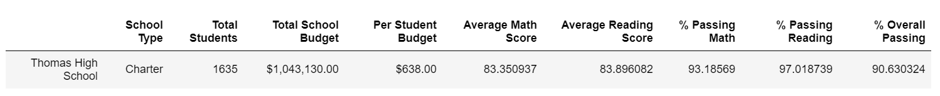

**Figure 4: 10th – 12th Graders Summary**

To provide further analysis, 9th graders scores for math, reading, and overall performance was replaced using grades 10th-12th data for KPIs “passing math”, “passing reading”, and “passing math and reading” for school summary. By doing so, we found that that the 10th -12 graders have a very high scores in relation to the school district with a 2nd place ranking in the district (Figures 5-8).



**Figure 5: Original School Summary**



**Figure 6: Replaced School Summary with 10th – 12th grade values.**

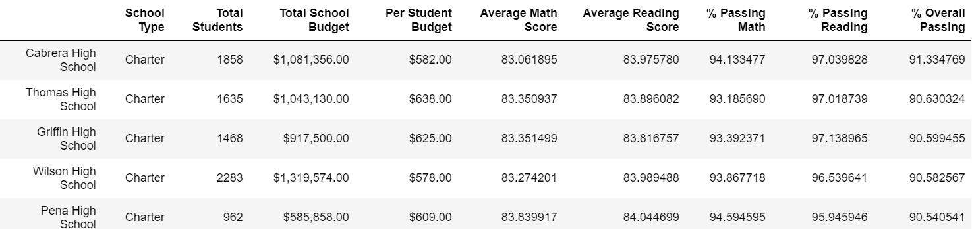

**Figure 7: Top 5 Schools by Overall Passing %**

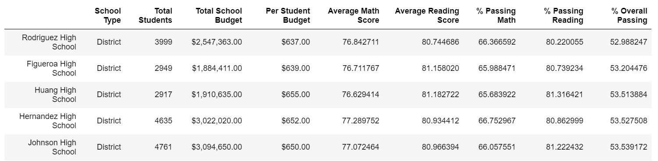

**Figure 8: Bottom 5 Schools by Overall Passing %**

With our new data sets, we found that Thomas high school ranks 2nd in the district with spending per student ($630-644). Compared to others in this spend per student bucket, Thomas High School ranks higher with the replaced math, reading, and overall passing scores with averages being 73%, 84%, and 63% respectively (Figures 9 and 10). It was also identified that schools with smaller population of students had the best scores in all key performance metrics for math and reading. This data is consistent across all 15 schools within the districts with highest performance schools having a smaller population sample of less than 1000 (Figures 11 and 12). Lastly, type of school (District vs Charter), also had a key factor of Thomas and other schools with Charter schools having higher performance metrics vs their District counterpart (Figure 13). With Charter schools, overall passing averages were in the 90% whereas District counterparts were in the mid-50s at 54%.

In conclusion, the 9th grade class under performed compared to their 10th -12th grade counterparts at Thomas High School either through underperforming or through academic dishonesty. By replacing the 9th grade outliers, Thomas High School is ranked 2nd out of their district and performed high against other schools within their budget by student and school types. With this data replacement, Thomas high school changed in ranking from the middle low to high performing within the district, average scores in math and reading, as well as passing percentages for their subjects.

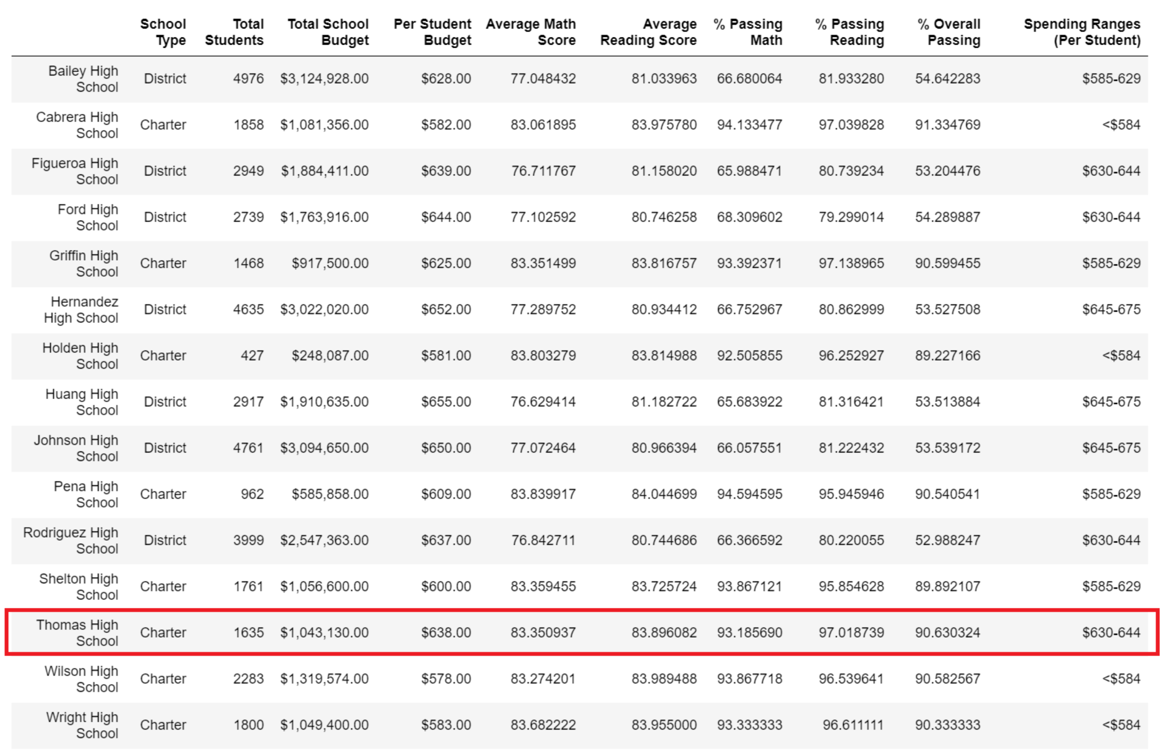

**Figure 9: Schools vs Spending Ranges**

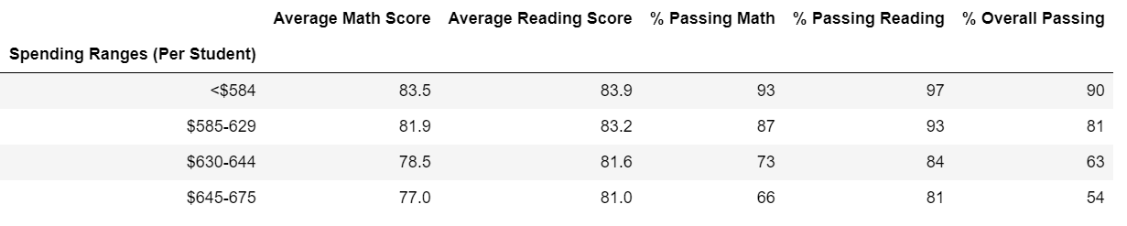

**Figure 10: Average Spending by Student vs Performance**

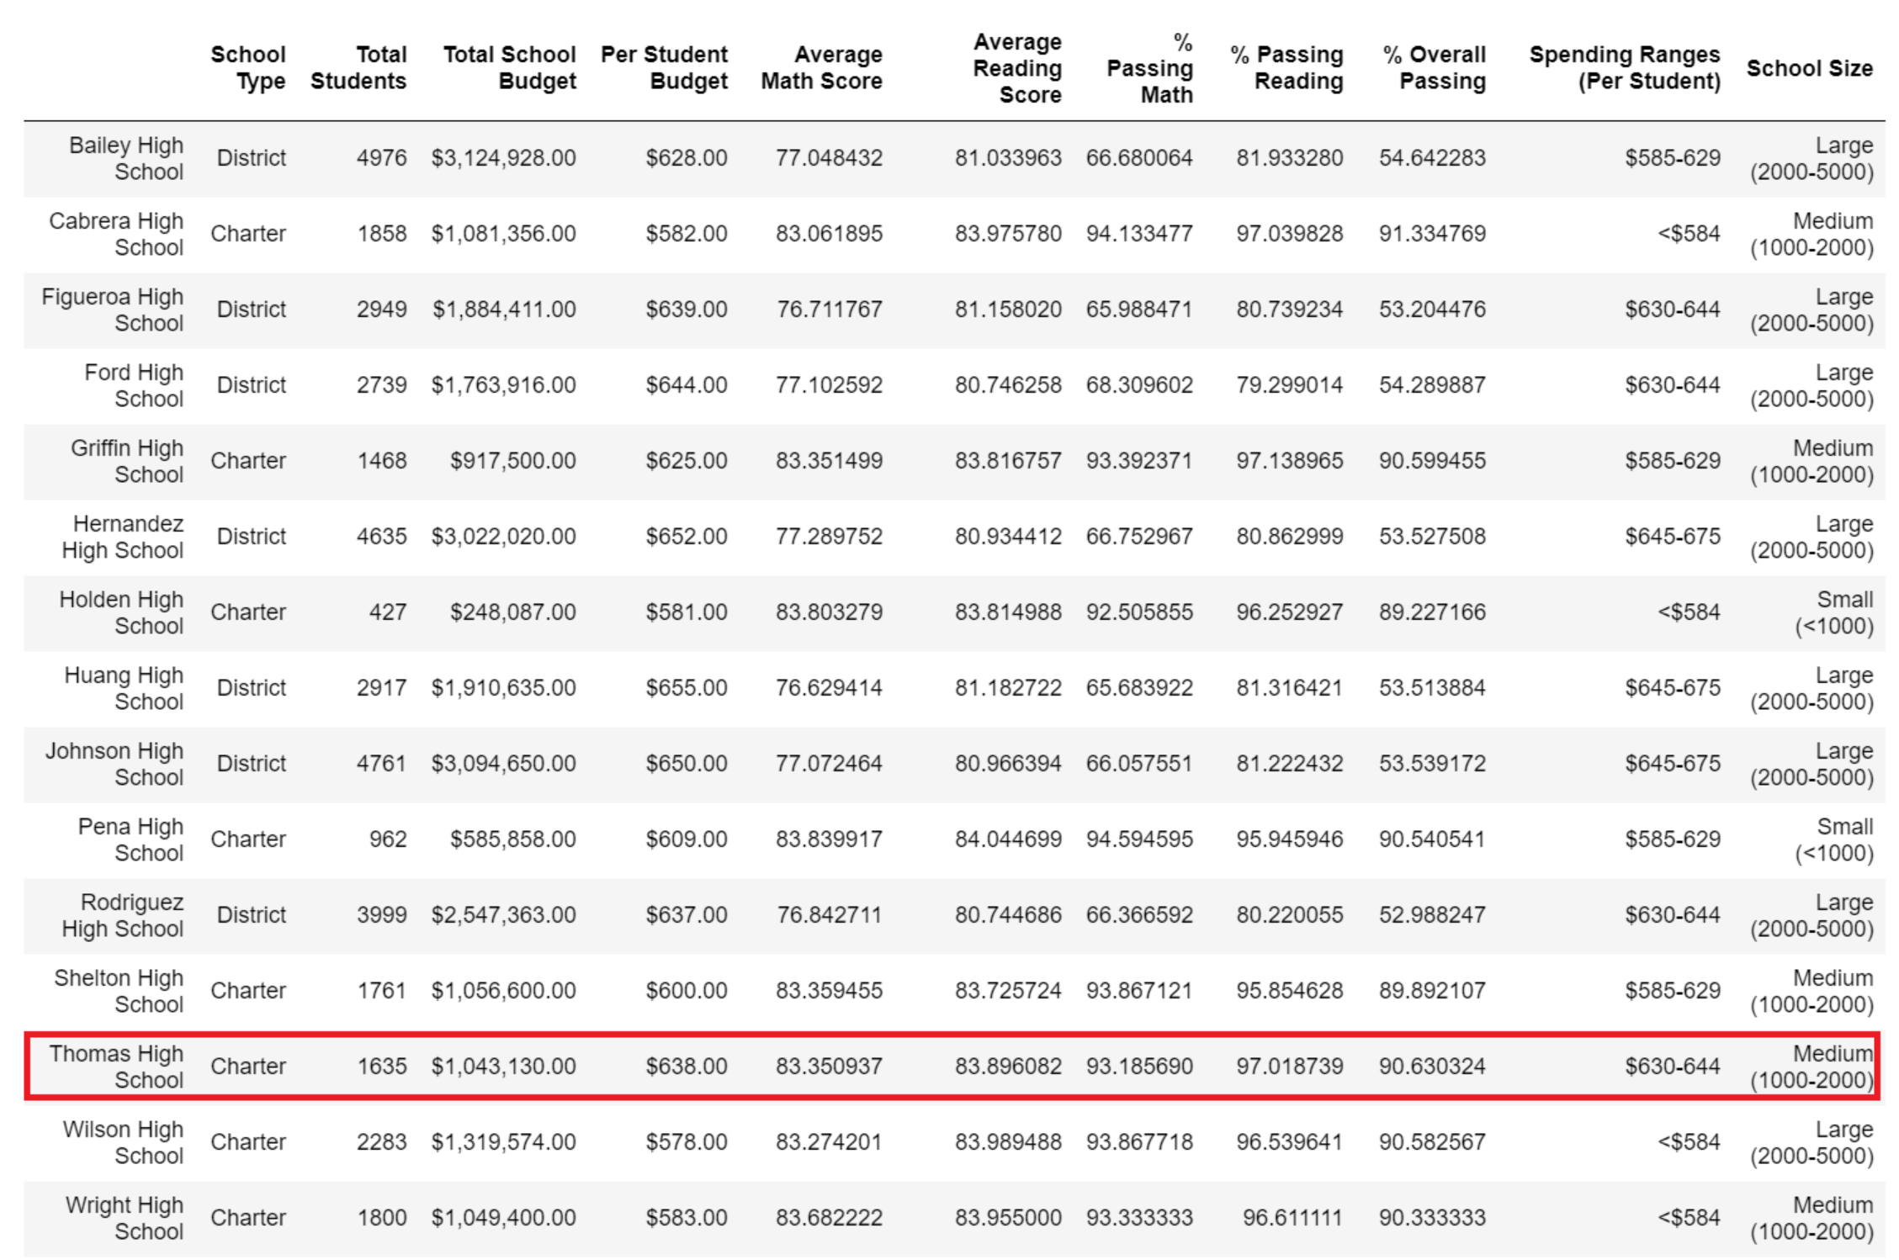

**Figure 11: Population Size by School**

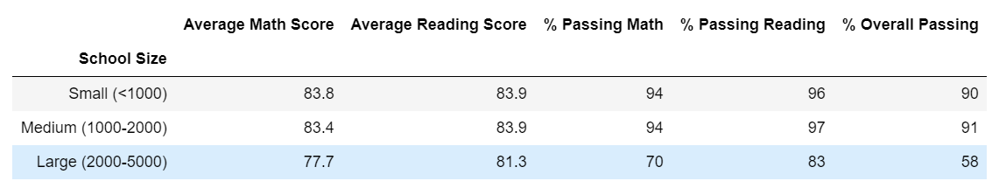

**Figure 12: Population Size by School vs Performance**

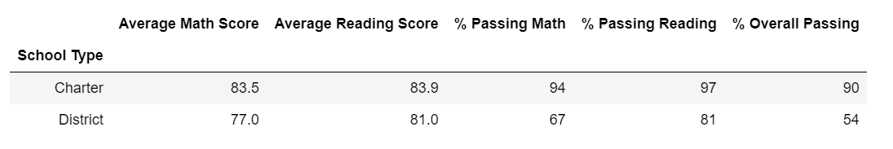

**Figure 13: School Type vs Performance**